Important changes to our appointment system

Total Triage- GO LIVE 8th January 2024

From Monday 8th January we will be introducing a 'Total Triage’ appointment system. We will transition from our current hybrid model of eConsult, telephone and walk-in booking to a ‘total triage’ model. We will continue to operate an ‘On the day’ service. Please contact the practice on the same day you wish to receive a response.
We are increasing our eConsult operation times to 06:30am-12 noon Monday to Friday. This will ensure that we are able to deal with all eConsults safely and appropriately within the correct time frame. Should you have a need for urgent input after 12noon, you can call reception as usual and you will be asked a few questions to fill an ‘eConsult lite’ via our Reception Staff. This helps to ensure that your enquiry is dealt with by the correct person.
All incoming online consultations, both eConsult, and eConsult Lite will then be triaged by a clinician, who will decide on the most appropriate mode of care delivery.
We aim to respond to all eConsults within 48 hours, but most will be the same day. If you have submitted an online consultation, there is no need to call the practice to check we’ve received your request, please be assured we will contact you.
Thank you for your patience and understanding during this time. These changes are being made to improve our access and to help our patients to gain the most appropriate advice and assistance in a safe and more efficient way.

How it will work
Patients submits an enquiry in their own time (between 06:30am and 12 noon) through a structured online consultation form via the practice website, or patient phones the practice and administrative staff complete an online consultation form (or a shortened version as a template) on behalf of the patient.
Administrative staff filter admin requests and send clinical queries to the most appropriate clinician flagging urgent requests.
The clinical history is presented in a way that is quick and easy to assimilate. Clinician responds through the most appropriate channel.
The outcome:
- Text message or Email
- Video consultation
- Telephone consultation
- Face-to-face consultation
- Physio ‘self book’ link – pt to book an appointment convenient for them directly into our system
- Advice and guidance- web link, self help guidance
- Prescription and notification

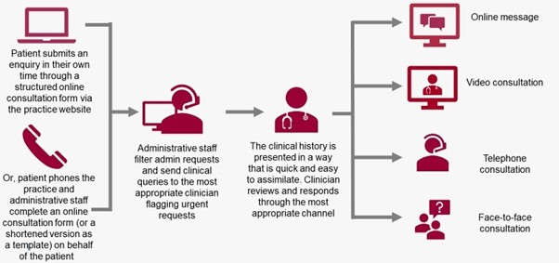

FAQ’s

What is total triage?

Total Triage means you will be asked to contact the surgery by eConsult for all your admin and clinical queries. The Doctor will review all clinical eConsults and patients will be allocated to the most appropriate service. This may be a Doctor, The Triage Team, Physiotherapist or other community services. We will continue to operate an on the day service.

What if I do not have access to a computer or cannot complete the form myself?

You may ask a friend or relative to help you. If this is not possible, you may call the surgery- our staff will ask you the questions in an ‘eConsult lite’, which will provide enough information for the clinical staff to review. The answers will then filter through the same channel and be managed accordingly.

I do not like the eConsult form and find it time consuming

Whilst we have eConsult commissioned by our Integrated Care Board (ICB) We have listened to this feedback and tried several other products on the market. Currently we have not found a product that satisfies both patient ease at completing the form versus clinical safety and ‘red flag’ alerting. Therefore, we will continue to research but for now we will move forwards with eConsult. We do feedback directly to eConsult with your comments and whilst we appreciate this will not satisfy all, we hope that you will find great care and timely responses to your requests.

How will I be responded to by the practice to know what I need to do?

You will be contacted by the practice on the day of your eConsult in the following ways: Telephone, Text, email.

GP appointment
For GP appointments, you will be added to the GP list (your own or your requested GP where possible). The GP will then review in full your request and respond by Phone, Text or email as appropriate. (you may add what method of contact you would prefer within your eConsult)

GP Appointment- Face-to face
For anything Triaged that will be better seen Face-to-Face- an appointment will be booked for you and a text message will be sent confirming the time of your appointment with a reply facility for you to confirm you can attend at that time. Should you wish to change this you can reply or call reception.

Physiotherapist or Practice Nurse
For Physio appointments, you may receive a ‘booking link’ to book a face-to-face appointment at a time convenient for you (we have a Physio working at The Wilson Practice Monday-Thursday weekly)

Self-help/ Further advice
You may receive a text or email with further advice/ information about a condition or drug that will be helpful to your query

I do not want anyone to see my information other than my doctor

Our Reception team do need to ask basic questions for the request to filter into the eConsult clinical triage system, and to ensure that each query is allocated to the correct clinician. We would like to assure you that all staff are trained in data protection and confidentiality.

Are the opening hours going to change?

YES! eConsult will be our main method of communication. The initial opening times for eConsult from 8th January will be 06:30am- 12 noon. Our phone lines and building will remain open from 08:00am-18:30pm. We hope that opening up the access to eConsult will be more convenient for our patients and ease our phone lines creating a much quicker answering time. We will be monitoring the opening hours and hope to extend these however we are integrating into a new way of working so please bear with us.

